Mask Mandate Quiz

The Game is Simple, Pick the Spot on the Chart Where the Mask Mandate Went into Effect

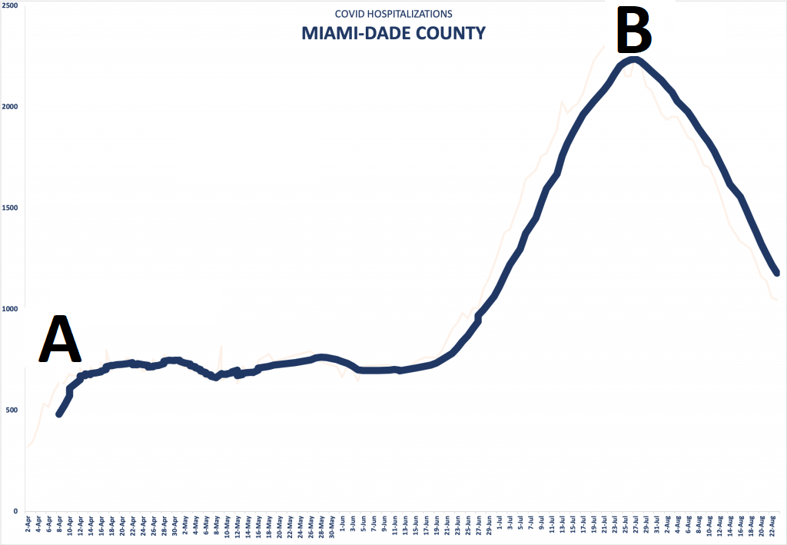

Answer: _________________

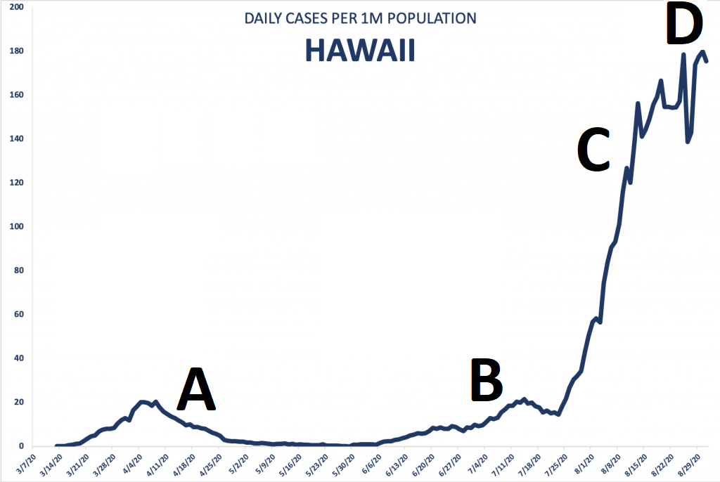

Answer: _________________

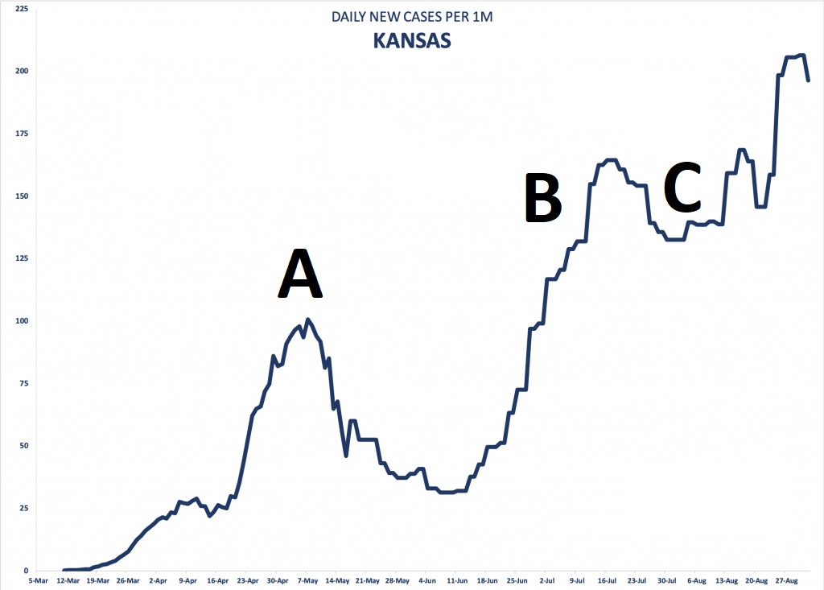

Answer: _________________

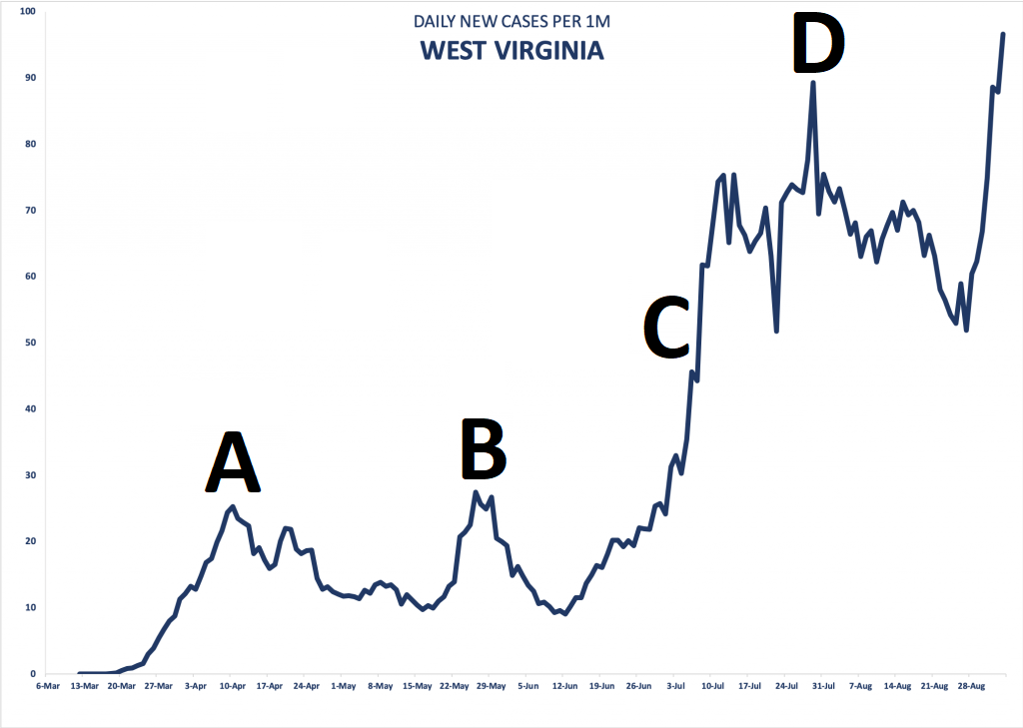

Answer: _________________

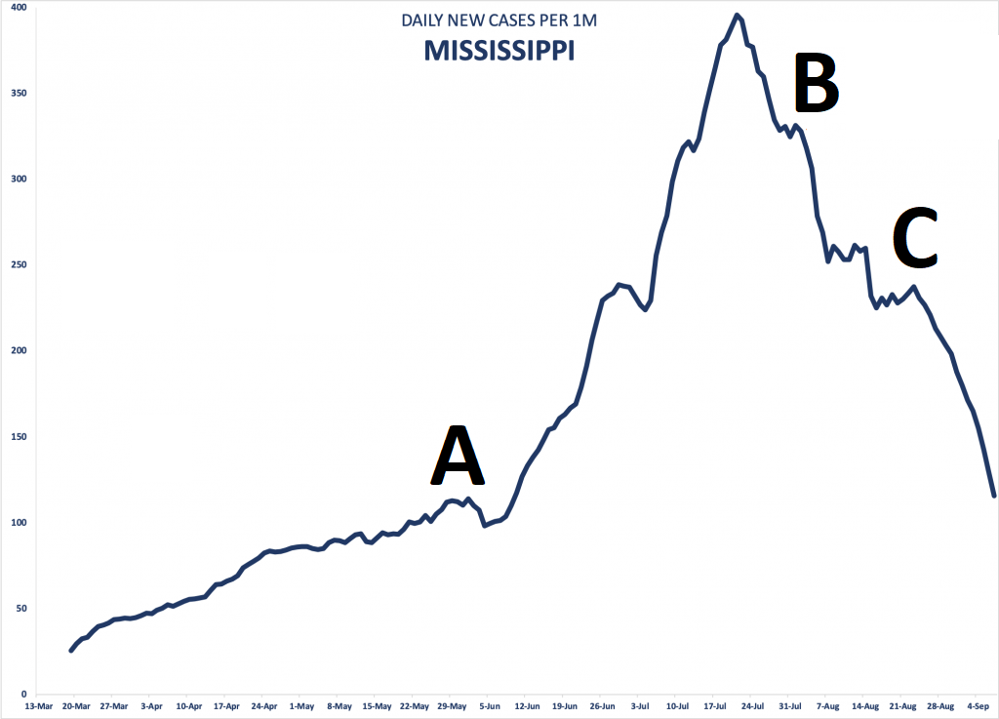

Answer: _________________

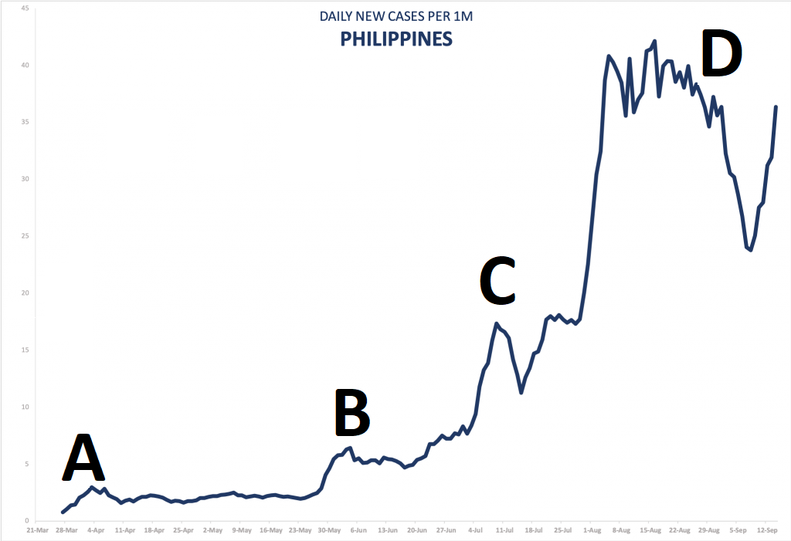

Answer: _________________

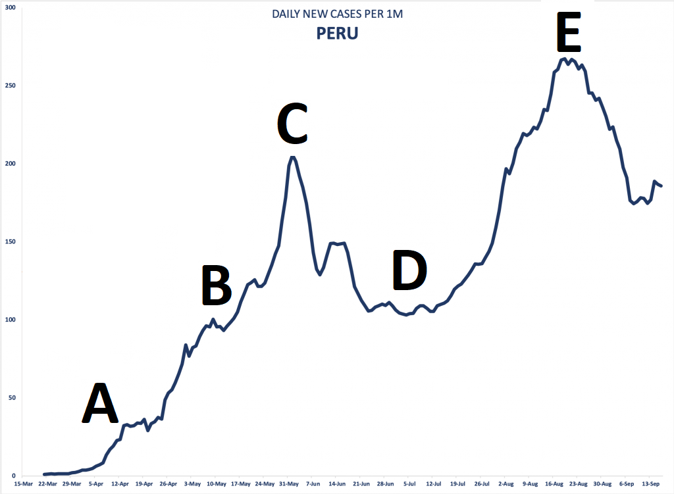

Answer: _________________

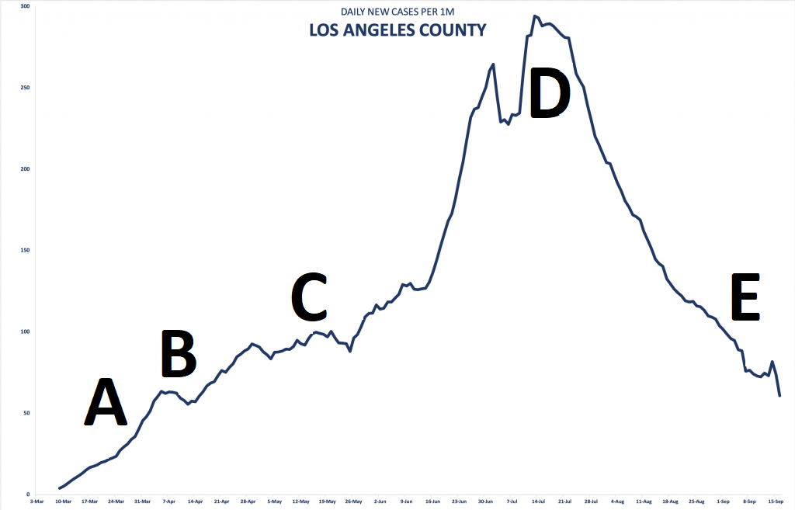

Answer: _________________

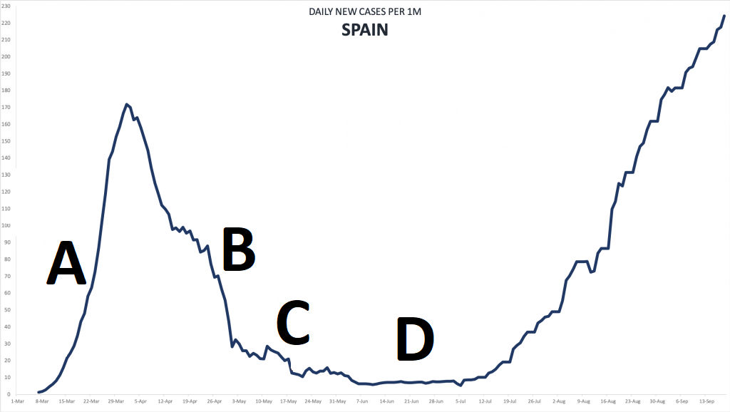

Answer: _________________

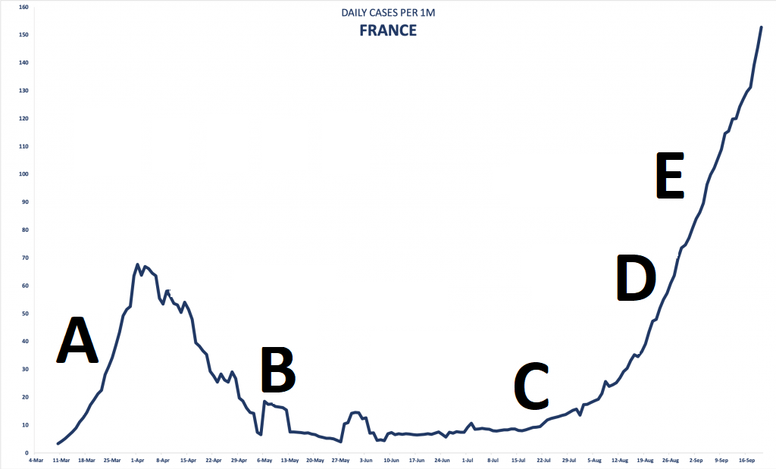

Answer: _________________

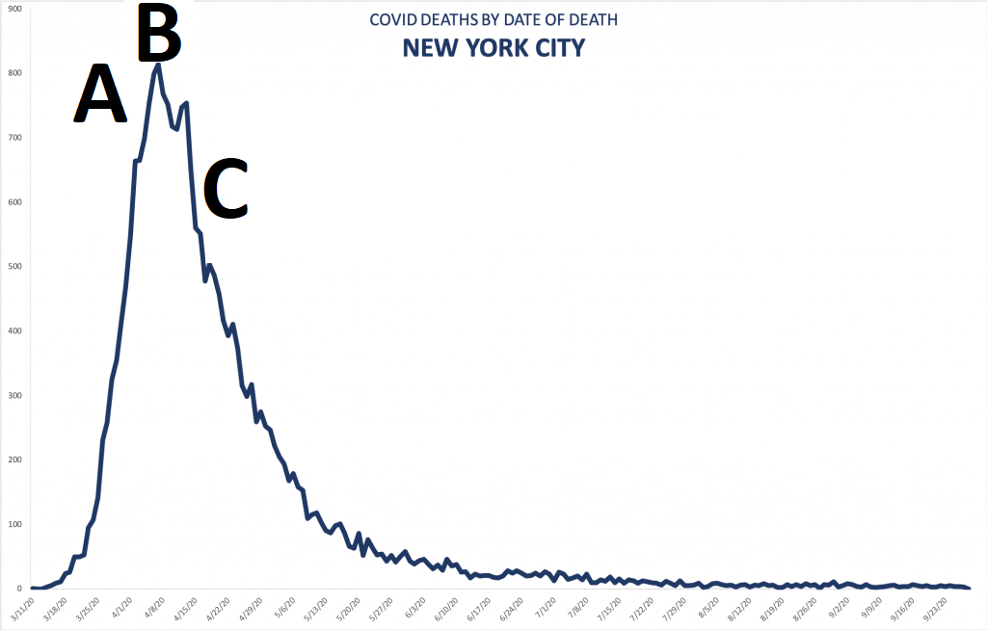

Answer: _________________

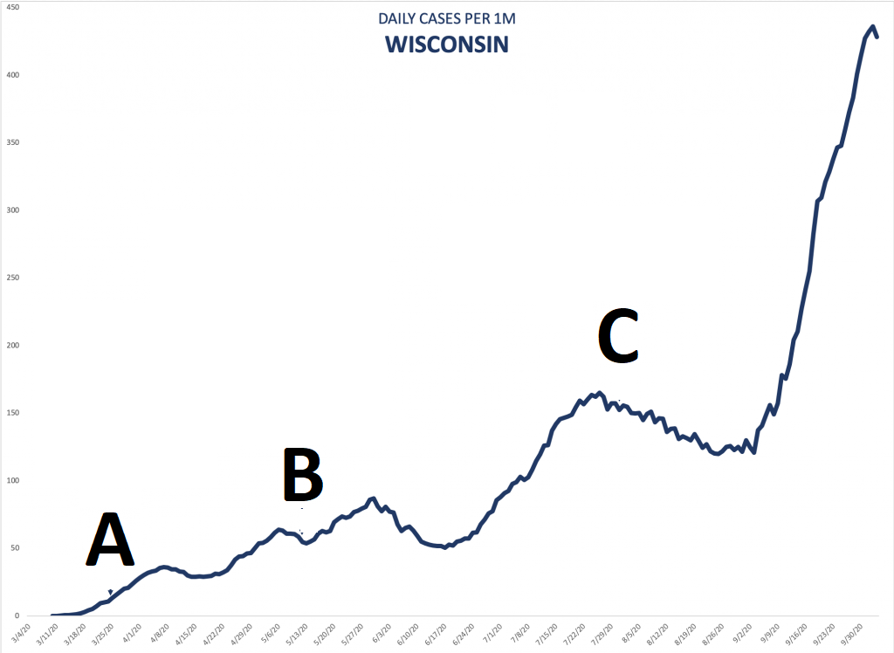

Answer: _________________

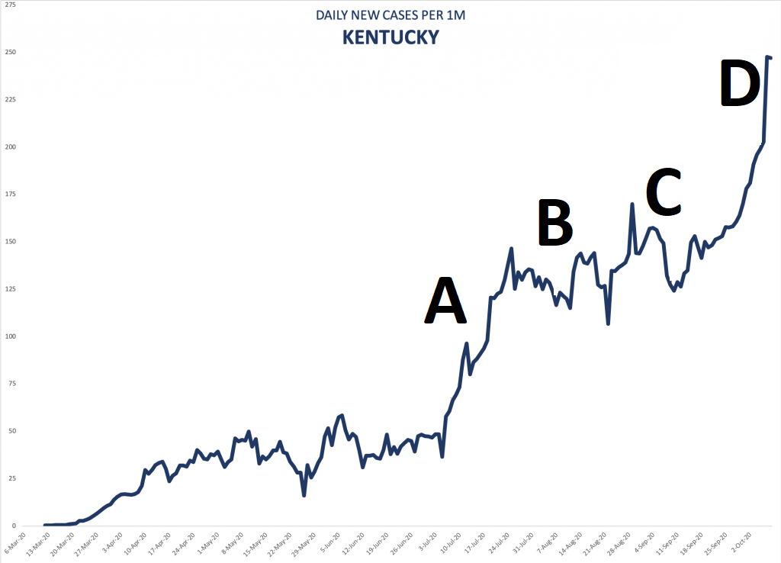

Answer: _________________

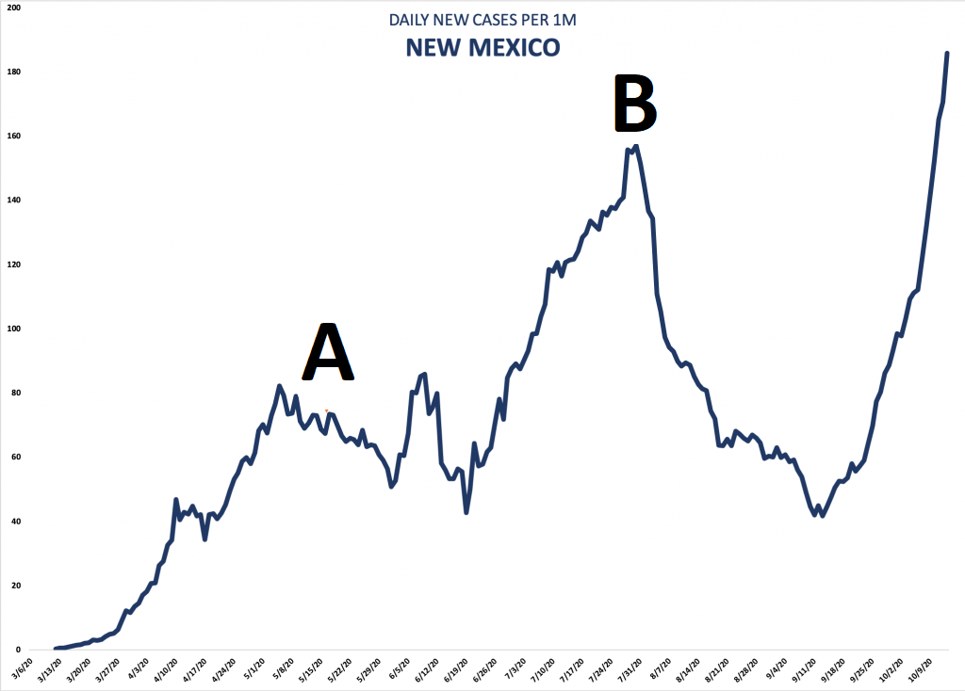

Answer: _________________

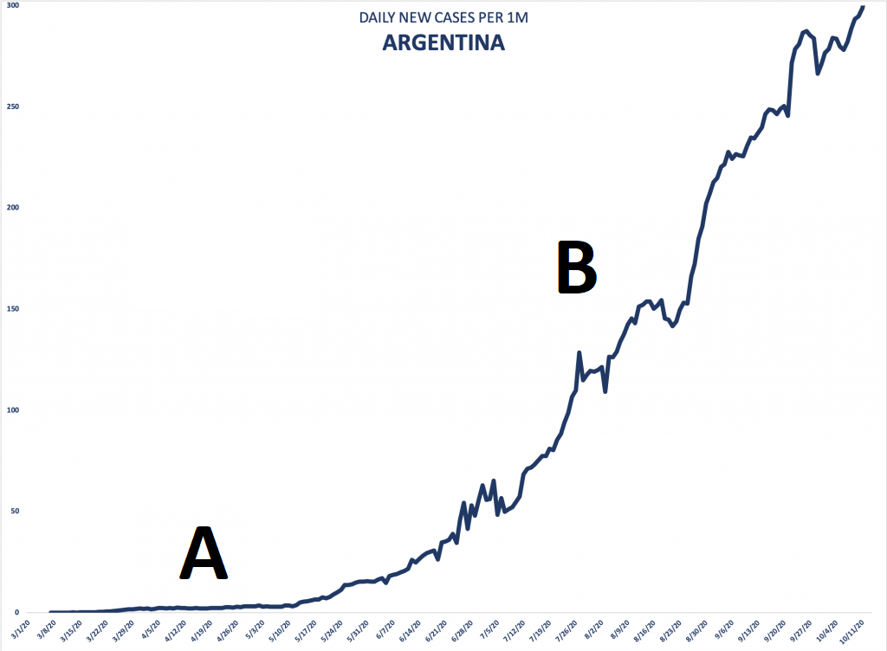

Answer: _________________

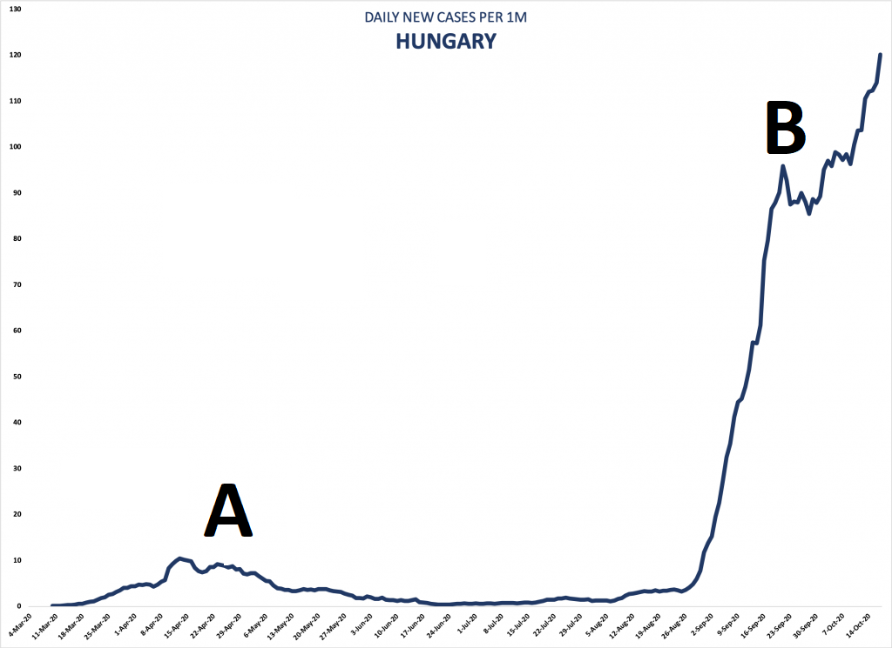

Answer: _________________